YPCE Residencies 2024
Memorandum of Understanding
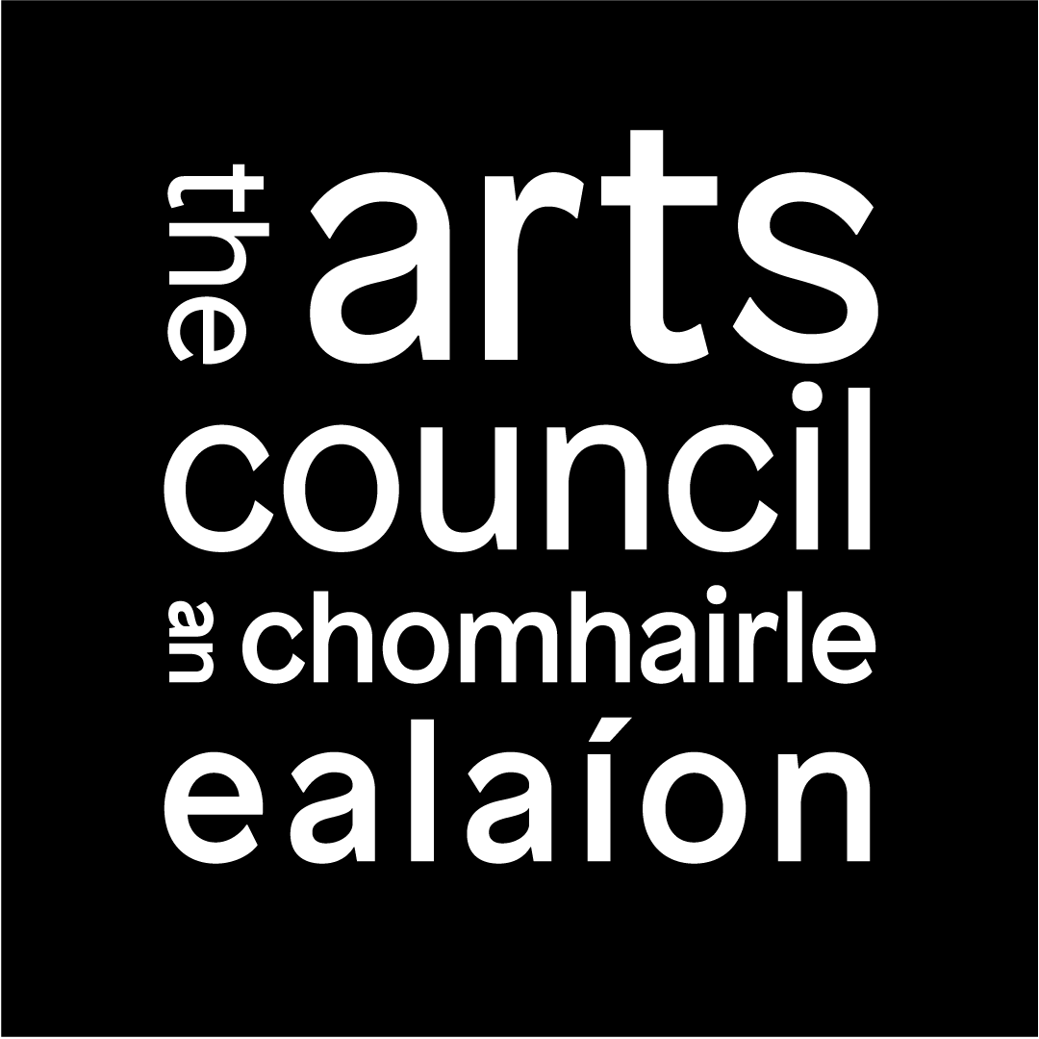
This memorandum of understanding MUST be explicitly agreed between the host institution and the individual artist or arts organisation. The Arts Council assumes that both parties have contributed and committed to its contents.

Parties to the memorandum of understanding
Host institution:
Lead artist or arts organisation:

Agreed aims
As parties to this agreement, we confirm that we understand the Arts Council’s overall aims in supporting YPCE Residencies (see Guidelines for Applicants section 1.1). In addition, in developing our proposal we have agreed the following specific aims for this residency:

Commitment
Please note:
- If the resident artist/arts organisation has agreed that a portion of their/its fee will be used to support the contribution of other collaborating artists, it is essential that the artist’s or arts organisation’s commitment to managing payments to other artists is reflected in this section. In addition, a detailed budget must be submitted outlining how payments to collaborating artists have been calculated.
- The host institution should make sure to include any administrative, technical and financial support it will put in place in order to host the residency.

The commitments of the parties to this agreement are set out below.
The artist/arts organisation will:

The host institution will:

Scope of the residency

Below is a breakdown of how the resident artist’s/arts organisation’s time will be spent.
Activity | Proposed number of days | Proposed time frame

Summary
* Residency start and end dates: | From _/_/_ To: _/_/_
Total number of days the artist/arts organisation commits to the residency:
Total fee to the artist/arts organisation as outlined in the budget:
Of which the amount (if any) that will support the participation of artistic collaborators:

* Note: in order to allow sufficient time for assessment of applications, residencies should commence no sooner than June 2024. The duration of the residency should be no longer than twelve months.

Declaration of agreement
On behalf of the institution:
Name:
Position:
On behalf of the artist/arts organisation:
Name:
Position:

